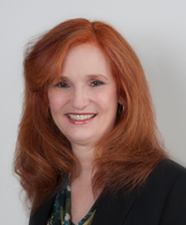
Susan Friedman BSN, RN
Susan has been a registered nurse since 1978 with a focus on pediatrics. She lives in Livingston, New Jersey, has been married for almost 35 years, and she and her husband have raised three children.
Susan and her family have been members of B’nai Shalom in West Orange, New Jersey since 1990. She is also a member of Sisterhood and has done programming related to essential oils.
Over the years, Susan has assumed many leadership roles in her shul and at her children’s day school. For eight years, she co-chaired the parent advocacy group for children with learning differences at Solomon Schechter Day School (now Golda Och Academy). This group met monthly, and Susan was responsible for programming open to all, as well as a newsletter sent to each parent who had a child with documented accommodations in the school. She has worn many hats at B’nai Shalom, including being a co-president of the shul during the transition period of a beloved rabbi retiring and the new rabbi beginning his tenure. Susan is known to step in when there is a need and to follow the project to completion.
Professionally: Susan works for Prince Health, LLC as the Director of Health Care Professional Education. In this role, she researches the current standards of care and best ways of communicating to improve patient engagement. She is part of the team a presents workshops on patient engagement and reviews printed material prior to presentation.
Volunteerism: Susan has been with the Creating a Caring Community Together program since 2016. She was one of the members who went to Israel in 2017, and she continues to be part of the committee. Susan joined the chaplaincy committee in the fall of 2017 and is part of the CARES committee. She is a Court Appointed Special Advocate for Children, and finds that the information she has learned through workshops can be applied to her roles within the Creating a Caring Community Together Committee.

