Prior to event:
Date | Need | Action | Status
Oct., Dec. | Publicity for Dec. 25 event | Place article in Nov-Dec. monthly bulletin.
Oct. | Publicity for Sisterhood Cookie Baking day | Place article in Nov-Dec. monthly bulletin.
Oct.-Nov. | Reserve Room, room set up | Reserve a room. Include request for tables and table set-up. (see below/ last page). Try to get the room for 1-3 days before Xmas to set up, leave supplies.  Get a portable microphone for day of event.
Nov.-Dec. | Assess and purchase supplies: Buy cookie (bakery) boxes, tissue paper, art supplies, etc. (See table “What to Bring” below.)  2013 costs: $100 for breakfast; $18 for tablecloths; $55 for boxed cookies and candy; $43 for bakery boxes. | Bakery boxes: Need est. 130-140 7 X 7 X 4 inch boxes annually. Boxes should be purchased by someone with a resale license from a restaurant supply company (e.g., Restaurant Depot) to get the best price. Our estimated cost was $45 for 200 boxes.  Tissue paper: Same amount (for 130-140). May want to buy doilies instead or in addition.  Table covering: Plastic tablecloths, butcher paper, or rolled plastic.  Hand sanitizer: 4-5 small or one large bottle.  Other: Scissors, scotch tape, tape to tape maps on the wall; may want to buy candy canes and chocolates to add festivity to the boxes. Decorations: (optional) Ribbon, curling ribbon, etc. to wrap boxes closed and make look festive. Art supplies (optional) for kids to decorate boxes.  Keep receipts to be reimbursed by Sisterhood.
Nov.-Dec. | Sisterhood group cookie bake | Date should be put on synagogue calendar, kitchen should be reserved, and publicity for the group cookie bake should go into monthly, Shabbat and e-bulletins for Dec.
Dec. | Publicity | Put notice in Shabbat and e-bulletins for month of December about Dec. 25 event.
Dec. | Routes and maps of Austin.: Synagogue donated label stickers for cookie boxes | One of our members put all information into a cloud app that could be shared (Google maps) to create a link to the routes, since most people have smart phones. Have a copy of the routes (maps and directions) to hand out to people who don’t have smart phones, or have a laptop and printer to print the directions. (See Christmas Cookie Project Route Chart for our example.)  Send file to Synagogue to print labels with greetings (“Thank you for serving your community on this holiday and every day. From Congregation ***) to put on cookie boxes.  Get a couple of street maps of Austin to put on the wall with carpenter’s tape (tape that doesn’t ruin the walls.) Mark locations on maps.  In future years – Get information about new/changed fire stations, police stations, hospitals to update the information.
Dec. | Buy, borrow, or loan other supplies | 30- 50 pair of food handler gloves (small, medium, large).  10 pair of scissors, pens, sharpies.  Carpenter’s tape (tape that doesn’t ruin the walls.)  4-5 small bottles or one large bottle of hand sanitizer.  Name tags – need about 80.
Dec. | Directions for the day | Write out directions for the day to hand to people when they come in to volunteer
Dec. | Photocopy/Print | Sign-in sheets.  Directions for the day.  Print labels.
Dec. | Get microphone
Dec. 23-24 | Purchases | Pick up bagels, cream cheese, etc. since bagel shops will be closed on Christmas Day. Take stock that everything needed to be purchased is on-hand. Make sure everything from Synagogue is ready to go.  Make sure cookies are taken out of the freezer.
Dec. 24 (most places are closed on Dec. 25) | Purchase or arrange for items for “nosh” by members of the congregation (optional) | Bagels, etc.: Purchase 2-3 doz. bagels and 3 tubs cream cheese; Other: Sweet breads (e.g., Danish, sweet rolls, brownies from Costco);  Coffee, etc.: Arrange for coffee to be made (congregant) or bought or have instant coffee and pot of hot water (we usually just had instant coffee and a pot of hot water) + creamer, sugar, sweetener;  1-2 gal. juice;  Paper products: arrange for hot cups, napkins, utensils (to spread cream cheese), coffee stirrers. Ask Synagogue if you can take paper products and sweeteners out of kitchen.  Keep receipts to be reimbursed by Sisterhood.
Dec. 24 | Room set up (optional) | Arrange tables ahead of time; can put tablecloths on; bring boxes in; bring cookies up; set up coffee/nosh station, sign in table, donation ($$) jar, etc.

Things (supplies) to have at event on Christmas Day:
- Table coverings | - Microphone
- Clipboard for sign-in | - Sign-in sheets
- Pens, Sharpies | - Name Tags
- Maps | - Tape to mount Austin maps
- Copies of routes (maps, directions) About 70 locations. 1-4 boxes per location: 2 for EMS; 1 for police and fire; 4 for Hospitals. | - Copies of Directions for the day.
- Master list of organizations | - Gloves
- Cookie boxes | - Tissue paper
- Extra Cookies (2-3 dozen); cookies Sisterhood baked out of kitchen/social hall. | - Candies (optional)
- Art supplies (optional) (e.g., glue, glitter, yarn, markers), 10 pair of scissors, ribbon, curling ribbon, Scotch tape | - Labels with Synagogue greeting; with name of destination
Nosh items:
Bagels & Cream Cheese, 3-4 spreaders | Sweet breads
Coffee, Creamer, stirrers, sugar, sweetener, cups (hot and cold) | Napkins
Juices | Donation Jar and sign

Christmas Day, prior to boxing and delivering cookies:
- Arrive at 8:30.
- Set tables where wanted. Wash down tables if needed.
- Cover tables with paper or tablecloths.
- Set up/make coffee.
- Set up food for nosh (2 tables): slice bagels; put out cream cheese, inexpensive sweets, and coffee, etc. for 9:30 schmooze. Put out a Donation Jar to collect donations for the nosh.
- Get cookies that were taken out of freezer.
- Set supplies out, including:
- Boxes, tissue paper and/or doilies, and box labels;
- hand sanitizer and gloves for people packaging cookies;
- ribbon, scissors, pens, sharpies
- Put maps on wall
- Put sign-in sheets and name tags on sign-in table.
- Have paper copy of route maps available.
- Put directions for the day on sign-in table.
- Put pens and Sharpies on sign-in table
- Test microphone

Stations and Descriptions:
Process of getting cookies boxed and out the door on Christmas Day
Sign in – 1 table. As people arrive, have them:
- Sign in to indicate who they are and what they’re contributing.
- Make a name tag.
- If they bring cookies, have someone take the cookies to the cookie station.
- Ask them to help with stations and assign volunteers who are willing.
- If they want to deliver cookies, have them select a route. If they have a smart phone, provide them info on accessing the Cloud app; if not, provide a copy of the route maps with delivery name, location, and directions to them. Mark up wall map and location that delivery is being made.
Snacks – 2 tables, with beverages, snacks, etc. for volunteers.
Box building – 1 table
- Have volunteers build 3-D boxes at box building station.
- Line with tissue paper or doily.
- Decorate boxes (optional).
- Take to cookie station.
Cookie station – 8-10 long tables in a long row. Area where cookies are initially brought, and where cookies are put into bakery boxes.
- Fill boxes with a variety of cookies. Separate layers with tissue paper, if using. Fill as many boxes as possible before handing any out.
- Take to tying station.
Tying station – 2 tables
- Close boxes and tie with ribbon.
- Put Synagogue greeting label (“Thank you for serving your community on this holiday and every day. From **** Synagogue”) on box.
- Take to completed box station.
Box Completion station – 4 tables
- Stack filled boxes until deliveries are made.
Announcements: explain what will happen next. Direct people into an orderly line to make boxes, fill boxes with cookies, etc.
Destination station - 1 table. (Near maps on the wall.)
- Have someone who can help people locate where they’re delivering the cookies.

Etc. notes
- In the past, the coordinator bought several dozen cookies since there weren’t enough brought.

Wrap-up (after event is over)
- Write a report (like this one) and send to Sisterhood president. This should be done by the person who coordinates on the day of the event.
- Write small piece for Synagogue bulletin thanking congregation for their participation and giving some stats. This should be done by the Social Action chair or Sisterhood President.

Table Layout

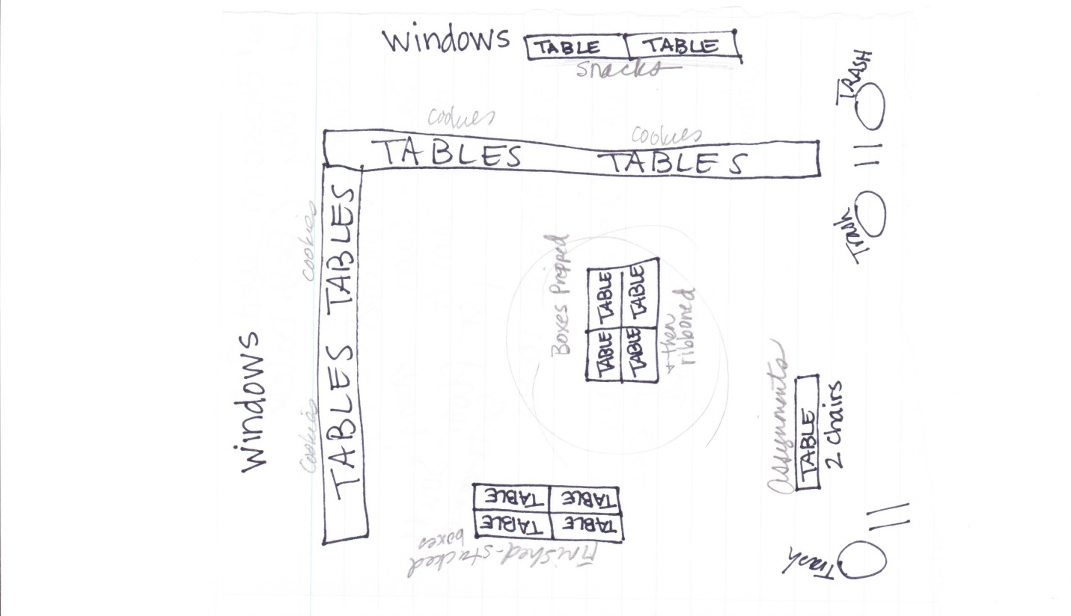

Here’s the blurb that went in for 2015. Includes a graphic. Sisterhood Baking Day, Thursday, December 17, 9 a.m. Do you like to bake and share time with new and old friends? Sisterhood is organizing a baking team to bake goodies for our annual Christmas Cookie Project! Please come and have a fun day baking with us in the CAA Kitchen! If you have questions, please email *****.
May be done ahead of time.

